#### 

**PROJECT TITLE: IMPLEMENTING USABILITY IN STUDENT MANAGEMENT SYSTEMS**

**NAME: JOHN KANG’ETHE KARANJA**

**SUPERVISOR: DR. DENNIS NJAGI**

**A PROJECT PROPOSAL SUBMITTED TO THE DEPARTMENT OF INFORMATION TECHNOLOGY IN THE SCHOOL OF COMPUTING IN PARTIAL FULFILLMENT OF THE REQUIREMENT FOR THE AWARD OF BACHELOR OF SCIENCE IN INFORMATION TECHNOLOGY AT JOMO KENYATTA UNIVERSITY OF AGRICULTURE AND TECHNOLOGY**

**AUGUST 2024**

**DECLARATION**

I declare that this is my own and original work and has not previously submitted to any university for the awarding of the course marks. To the best of my knowledge and belief, this work contains no material previously published or written by another person except where due reference is made.

STUDENT NAME:

JOHN KANG’ETHE KARANJA: ………………………………………….

Signature: ………………………………………….

Date: …………………………………………. ………………………………………….

APPROVAL

The project proposal of JOHN KAN’GETHE KARANJA was reviewed and approved by the following:

SUPERVISOR NAME: DR. DENNIS NJAGI

…………………………………………

Signature:

………………………………………….

Date:

…………………………………………. …………………………………

**DEDICATION**

I hereby dedicate this project to my beloved parents and all my family members who have enabled me to pursue this degree until the end. They have been a great contribution to my education and as a result I dedicate this project to them.

**ACKNOWLEDGEMENT**

I thank God for the far he has seen me in my studies and for giving me strength to do my studies. Additionally, I want to thank my family members for sponsoring and being always there for me. Without their support financially, morally, mentally and physically I would not be this far. To all my lectures thank you for impacting knowledge to me so as to reach this far especially my supervisor DR. DENNIS NJAGI and all other lecturers for being there for me.

**ABSTRACT**

The usability of a system lies in the effectiveness and ease-of-use of a system. The main function of the Student Management System (SMS) is to assist high school staff to manage students’ records. A student record embodies student admissions, finance, examination, accommodation and other essential information. The purpose of this research project is to evaluate the concept of system usability. It subsequently observes and analyzes the usability of a Student Management System at a high school level by applying Nielsen’s heuristic evaluation method. As a preliminary study, the usability of SMS at Magumu High School in Kenya has been chosen and assessed. The research aims to show that the usability constructs selected are not being fulfilled in Student Management Systems and make recommendations on the areas which can be improved. The intent of the project is to develop a Student Management System which implements various concepts of usability.

**TABLE OF CONTENTS**

Contents Page no

Declarations ……………………………………………………………..1

CHAPTER ONE

Introduction ……………………………………………………………..2

Problem statement……………………………………………………….3

Proposed solution………………………………………………………..4

Main Objectives …………………………………………….………….5

Research questions………………………………………………………6

Justifications …………………………………………………………....6

Methodologies ………………………………………………………..…7

Requirements …………………………………………………………...7

Budget …………………………………………………………………..8

Scheduling…………………………………………………………...….9

Gantt chart……………………………………………………………...10

CHAPTER TWO

Introduction………………….…………………………………………11

Theoretical review …………………………………………………….11

Summary ………………………………………………………………12

# **CHAPTER 1**

**1.2 Background Information**

The secondary school educational system in Kenya has relatively transformed from small day schools to large full-fledged high schools. These circumstances are spurred by the enormous enrolling students and the Kenyan government sponsoring a part of the funding. In response to this transformation, the functions and qualities of student management at high school have been raised and questioned. Having a Student Management System, managing and retrieving information of thousands of students is more efficient and effective. As credits go to technology, computers and the Internet, the access is no longer limited within the school premises but could reach parents and financial sponsors for them to make decisions. Despite the great advantage, there is a fundamental need for usability constructs to be implemented in the systems.

Usability is a question of how well the users can use the functionality offered by software (Tanaka, Bim, & da Rocha, 2005). Usability engineering involves studying and designing ‘ease of use’ into a product (Battleson, Booth, Weintrop, 2001). According to the definition of usability by Nielsen: usability is about learnability, efficiency, memorability, errors and satisfaction (Nielsen, 1993). The current Student Management Systems still lacks proper implementation of usability principles including easy and efficient to learn, use and remember, few errors and user’s subjective satisfaction (Tanaka, Bim, & da Rocha, 2005). This research project aims at coming up with a Student Management System which implements the core concepts of Nielsen usability heuristics. The higher the usability of SMS would provide the user a better access to specific records, reduce training and supporting costs while increasing productivity.

**1.3 Problem Statement**

The current systems have limitations due to a couple of factors as listed below:

1. The current systems do not express errors in plain language but rather express in codes which makes it hard to diagnose and recover from errors.
2. The current systems contain inconsistent interfaces which makes it difficult to learn.
3. The current systems contain cluttered interfaces with too much irrelevant and rarely needed information preventing visibility of relevant units.

**1.4 Proposed Solution**

I propose to develop Student Management System which implements the core concepts of Nielsen usability heuristics which include aesthetics and minimalist design, recognition rather than recall, easy recognition diagnosis and recovery from errors, consistency and standards.

**1.5**

**1.5.1 Main Objective**

To develop a Student Management System which allows management of student records in a more usability focused approach.

**1.5.2 Specific Objectives**

1. To develop a system with aesthetic and minimalist design.
2. To develop a system that has consistent interfaces.
3. To develop a system that is easy and efficient to learn, use and remember.
4. To evaluate the appropriate evaluation methods for usability heuristics.

**1.6 Research Questions**

1. What are the pain points or challenges faced by users while using student management systems?
2. What are the most suitable technologies and tools for building robust and scalable student management systems?
3. What usability focused systems have already been developed in the field of student record management?
4. What usability evaluation methods can be used in student management systems?

**1.7 Justification**

The system will help institutions by providing better storage and access to student records due to its minimalist design and uncluttered interfaces. The system will also be able to help the institution in cutting down training costs and supporting costs since it will implement consistent interface items which will be easy to recognize rather than recall which makes it easy and efficient to learn and use it. The system will be online hence it will be accessible from anywhere. The system will help save time due to easy record access, easy navigation among others.

## **1.8 Proposed Methodologies**

Research methodology can be defined as the strategy or architectural design by which the researcher maps out an approach to problem-solving. The system development methodology that will be used for the development of the Student Management System is the Agile methodology, specifically the Rapid Application Development (RAD) model under it. This methodology allows the research to be broken up into small modules and handled separately and deliverables come in an incremental manner. The RAD model enables rapid delivery as it reduces the overall development time due to the re-usability of the components and parallel development.

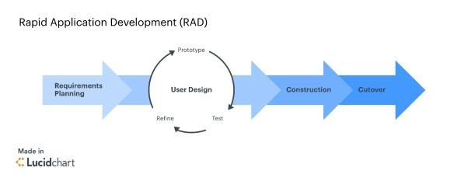

## **1.9 Data Collection Tools**

Data collection tools are used to gather information from various sources to help inform decision making and improve processes. The data collection techniques to be used are;

1. **Interviews.**

I will interview a random selection of staff. This involvement will allow the target interviewees to provide open-minded ideas and opinions, as well as allow me to request further explanation where necessary. Interviews also allow respondents to ask questions and offer suggestions that may provide vital recommendations that the interviewer did not record in their research. Engaging with them will help me find out whether the proposed system would make things better for them and what features they would like to see added in the system.

1. **Administering close-ended questionnaires.**

Closed-ended questionnaires can be an excellent technique to collect data since they allow you to ask standardized questions in a quick, straightforward and efficient manner. This can assist you in identifying particular areas where the system may require improvement as well as analyzing the data in a quantitative manner that is simple to summarize and interpret. Closed-ended surveys are very simple to use and can be used to collect input from a large number of respondents with varied levels of education or literacy.

**1.10 Scope**

The system will be viable for use by the Magumu High School management department.

## **1.11 Project Requirements**

### **1.11.1 Hardware Requirements**

1. Laptop – Core i3 and above
2. Internal Hard disk drive – 500GB
3. Processor Speed – 2.5GHz
4. RAM – 4GB and above
5. External hard disk – 1TB

### **1.11.2 Software Requirements**

1. Operating System – Windows 10
2. Text Editor – Visual Studio Code
3. Database – MySQL
4. Antivirus Software - Kaspersky

### **1.11.3 Other Requirements**

1. Bundles
2. Notepad and ball pen

**CHAPTER TWO:**

**LITERATURE REVIEW**

**2.0 Introduction**

Student management system (SMS) plays an important role in modern educational institutions by streamlining administrative tasks, enhancing communication between stakeholders, and improving overall efficiency. It represents a critical component of contemporary educational infrastructure, aiming to streamline administrative processes and optimize students’ performance. While formerly focusing solely on functionality, student management developers currently are wiser and more aware of the importance of addressing their customers’ needs in order to stay competitive in the market. The developers are now getting concerned with this usability issues including ease and efficiency of learning, use and remember, few errors and user’s subjective satisfaction (Tanaka, Bim, & da Rocha, 2005).

This chapter will dive deep into the implementation of Usability heuristics in student management, the current existing systems, and their limitations in comparison with the proposed system in this project.

**2.1 Theoretical Review**

The term ‘usability’ is not unexceptional in today’s system development and evolution. Traditional view of usability that is popular among software developers is the attributes of the user interface that makes a product easy to be used (Bevan, 2009). This view of usability is also consistent with the first International Standard Organization (ISO) definition of usability as part of software quality in ISO/IEC 9126 (Bevan,2009) as a set of attributes that bear on the effort needed for use and on the individual assessment of such use by a stated or implied set of users. The definition of user interface usability is in contrast with the system perspective of usability defined from an ergonomic point of view in ISO 9241-11 (Bevan, 2009) as the extent to which a product can be used by specified users to achieve specific goals with effectiveness, efficiency, and satisfaction in a specified context of use. In this context, the term usability is a maturing area that addresses interfaces, usability and interaction from human-computer interaction (HCI) (Ssemugabi, & Villiers, 2007). HCI is the study of how people interact with computer technology and to make this interaction effective is by providing the theoretical basis for applying usability concepts to software applications and computer interfaces (Battleson, Booth, Weintrop, 2001).

Several usability evaluation methods were proposed in the past to assist the system developers. The methods are either based on empirical and analytical (Blandford, et al., 2004). Empirical methods involve testing systems with users whereas analytical methods involve usability personnel assessing systems using established theories (Blandford, et al., 2004). Their selections are influenced by time, cost, efficiency, effectiveness and ease of application (Ssemugabi, de Villiers, 2007).

Among all, Nielsen’s heuristic evaluation method is most popular due to its expert review, easy to learn, fast and inexpensive (Tanaka, Bim, and da Rocha, 2005). This method involves evaluation by experts with expertise in the domain area and/or HCI.

Empirical research on student management systems encompasses a wide range of topics, including system design, features, implementation strategies and impacts on stakeholders. For instance, a study by Jones and Brown (2019) conducted a usability evaluation of a university’s student management system, identifying key areas for improvement in navigation, information presentation, and task efficiency.

Gupta and Kumar (2020) investigated the impact of the student management system on student academic performance, finding a positive correlation between system usage and grades, particularly among students with access to personalized learning analytics. Moreover, Sarker and Molla (2018) explored the challenges of integrating student management systems with existing institutional infrastructure, highlighting technical barriers, data security concerns, and resistance to change among faculty and staff.

Findings

Theoretical framework and empirical findings, student management system represents a dynamic intersection of technology, education, and organizational change. Theoretical models such as TAM and UTAUT provide valuable insights into the factors influencing SMS adoption and usage, while empirical studies offer practical guidance for system design. Implementation, and evaluation.

By integrating theoretical framework and empirical studies, educational institutions can develop more robust Student management systems that meet the diverse needs of stakeholders and contribute to improved student outcomes.

* 1. **Areas of application of usability in Student Management Systems**

### **Responsive Designs**

Usability has been applied in student management systems in the development of responsive designs which are capable of adjusting according to screen size and still offer proper functionality.

### **Overall User interface design**

Another powerful usability capability for building student management applications is the overall UI/UX design. It is applied in designing easy to use systems, easy to learn systems.

### **Efficiency and Effectiveness**

Usability is widely applied when developing student finance management systems in ensuring that the applications created are effective and efficient in their use

**2.4 Key implementations/case studies**

### **2.4.1 Case study 1: ISAMS**

ISAMS is a Brilliant Student management application which is a massive improvement that was long overdue. It features the ability to see everything in one place. It supports Academics, Administration, Admissions, Finance and well being

**Achievements**

Among the achievements of the system is **Calendar and timetable**, **Exam module, Reports and profiling**

**Comparison with the proposed system**

1. The system does not have consistent interfaces which will be key in the proposed system
2. The system does not offer error messages in plain language which will be key in the proposed system
3. The system has a cluttered interface which will be opposite in the proposed system

### **2.4.2 Case study 2: Clastter**

Classter School Management System is designed to streamline operations, enhance academic delivery, and foster a vibrant educational community. Classter is a SMS that adapts to your workflows and helps educational institutions meet the demands of contemporary education, ensuring administrators, educators, and students thrive in a supportive and efficient environment.

**Achievements**

Among the achievements of the system is **Real time academic tracking**, **Financial Management, Robust Reporting and profiling**

**Comparison with the proposed system**

1. The system does not have consistent interfaces which will be key in the proposed system
2. The system does not offer error messages in plain language which will be key in the proposed system
3. The system has a cluttered interface which will be opposite in the proposed system
   1. **Summary**

By applying the research area of usability to the problem domain of student management applications, developers can make better applications that are easy to learn, easy to use, efficient and effective among others.

* 1. **Research Gaps**
* **Error prevention and handling**: Further research is needed to assist in coming up with systems that provide means to easily recognize, diagnose and recover from errors.
* **Consistency and standards:** There is a need for further research to assist in developing systems that have consistent and standardized interfaces and interface items.
* **Aesthetic and Minimalist Design:** There is a need for further research to assist in developing systems that have decluttered interfaces.

By addressing these research gaps, the field of student management systems can further be advanced by developing innovative solutions that enhance student management.

**CHAPTER THREE**

SYSTEM ANALYSIS AND DESIGN

Introduction

The foremost goal of a System Analysis and Design is to show both the functional and non-functional requirements of the system. Fundamentally, this will be done using the UML object-oriented method since that is the main method to help in fully developing this system. This should be done with the aim to ensure that the proposed system is worth perusing and would fully solve the problem at hand. To achieve this, existing manual system will be used through the permission from the relevant people and compare it with the proposed system to determine whether it will bring a positive impact to the organization.

**System Development Methodology**

The system development methodology that will be used for the development of the Student Management System is the agile methodology, specifically the Rapid Application Development (RAD) model under it. This methodology allows the research to be broken up into small modules and handled separately and deliverables come in an incremental manner. The RAD model enables rapid delivery as it reduces the overall development time due to the re-usability of the components and parallel development.



1. **FEASIBILITY STUDY**

I carried out this study basically to understand how beneficial or practical the development of this student management system will be to this institution.

During the study I carried it out in four dimensions that included: Economic feasibility, Technical feasibility, operational feasibility and Legal feasibility.

Below are the outcomes of the study:

1. Economic feasibility.

During this feasibility study my core objective was to know whether the benefits of the proposed system will outweigh the cost incurred during the development of the system.

The outcome of the study clearly proved that the benefits will outweigh the cost since there will be no buying of papers and other writing materials now and then. Hence this system will remove an extra cost that has been there since the school started.

Below is a table to illustrate the estimated costs:

|  |  |  |
| --- | --- | --- |
| **Item No.** | **Item** | **Cost (Kshs.)** |
| 1 | Computer (Laptop 500GB HDD, 4GB RAM ) | 35,000 |
| 2 | Modem (Safaricom) | 2,500 |
| 3 | Flash Disk (8GB) | 1,500 |
| 4 | External hard disk (500GB) | 6,000 |
| 5 | Transport | 4,800 |
| 6 | Antivirus (Kaspersky) | 1,000 |
| 7 | Internet bundles | 3,000 |
| 8 | Maintenance cost | 3,000 |
| 9 | Miscellaneous | 5,000 |
| **Grand Total** | | **61,000** |

Return on Investment

|  |  |  |  |  |  |
| --- | --- | --- | --- | --- | --- |
|  | YEAR 0 | YEAR 1 | YEAR 2 | YEAR 3 | TOTAL |
| Total Benefits |  | 60000 | 67000 | 75000 | 202000 |
| Total Cost | 100000 | 10000 | 13000 | 18000 | 141000 |
| Net Benefits (TB-TC) | 100000 | 50000 | 54000 | 57000 | 61000 |
| Cash Flow | 100000 | 50000 | 4000 |  |  |

ROI

(Net benefits / Total costs)*100

(61000/141000)*100

= 43.26241135

= 43.3%

In relation to the above, the project will yield benefit to the institution if all the factors remain constant.

Therefore when using Cost Benefit Analysis, that is having done the comparison of the cost of implementing the system over the benefits of the proposed system, I found it to be economical feasible.

1. Technical feasibility.

During this feasibility study I purposed on knowing whether the solution that I proposed will be implemented with the available resources; hardware and software.

1. **Hardware**

There are approximately 50 computers in the institution each had a hard disk of 124 GB, Random access memory of 1gb and a processor with the speed of 1.7 GHz. Under hardware aspect of technical feasibility, I used observation as a method of data collections, where I was able to visit several offices in the institution.

1. **Software**

During my research I found that the offices used recent software’s such as Windows 2000/XP/2007, Microsoft Office 2003/2007 and above. Windows 7 was the mostly used operating system in most computers in the institution. Also most computers had been installed with Microsoft office 2007.

1. Operational feasibility.

The management of this school has ensured that all the workers in the institution are computer literate, hence this will make it easy for them to interact and understand the working of the system. The institution has a computer laboratory where workers go to train how to use a computer during their free time.

1. Legal feasibility.

Under this feasibility I purposed to know whether the proposed system will adhere to the laws and the rules of the institution .for example on data security and how data should not be exposed to an authorized people.

**Requirements Elicitation**

## **Data Collection Tools**

Data collection tools are used to gather information from various sources to help inform decision making and improve processes. The data collection techniques to be used are;

1. **Interviews.**

I will interview a random selection of staff. This involvement will allow the target interviewees to provide open-minded ideas and opinions, as well as allow me to request further explanation where necessary. Interviews also allow respondents to ask questions and offer suggestions that may provide vital recommendations that the interviewer did not record in their research. Engaging with them will help me find out whether the proposed system would make things better for them and what features they would like to see added in the system.

1. **Administering close-ended questionnaires.**

Closed-ended questionnaires can be an excellent technique to collect data since they allow you to ask standardized questions in a quick, straightforward and efficient manner. This can assist you in identifying particular areas where the system may require improvement as well as analyzing the data in a quantitative manner that is simple to summarize and interpret. Closed-ended surveys are very simple to use and can be used to collect input from a large number of respondents with varied levels of education or literacy. The sample questions are on the appendices.

**Data Analysis**

Following the sample questions above the findings will be defined as in the chart below.

|  |  |  |
| --- | --- | --- |
| **Role** | **Number of pple issued with the questionnaire** | **Number of respondents** |
| Students | 10 | 7 |
| Employees (teachers,nurse,etc) | 15 | 10 |
| BOM | 10 | 8 |
| Total | 35 | 25 |

The chart below shows different opinions of the people issued with the questionnaire.

|  |  |  |
| --- | --- | --- |
| Agreed | Disagreed | Undecided |
| 21 | 4 | 10 |

From the data collected, it was clearly that a high percentage of the respondents supported the implementation of a new system compared to those that opposed.

**FREQUENCY DISTRIBUTION TABLE**

This was used to analyze data .It was helpful to me in analyzing the data so as to be able to get user requirements for the new system.

|  |  |  |
| --- | --- | --- |
| Question (fx) | Score | |
| Based on quality of service and performance do you perceive the current system as adequate?  Have you used the internet before?  Are you ready to receive a new usable System? | YES | NO |
| 3  20  22 | 22  5  3 |
| TOTAL | N=25 | |

**N=the number of Respondents.**

**Graphical representation of the data analysis from the frequency table.**

1. SYSTEM SPECIFICATIONS

**Functional requirements**- In this type of requirement I will define the specific functions or activities that the system shall perform or what the system shall do.

Some of the features associated with this functional requirements are:

* Manage student registration- They system will allow the user to register student by entering their details such as name, admission no, form etc.
* Manage student finance – They system will handle all student fee payments for example generate report for fee paid and the fee balance of a student.
* Manage Student Health- the student management system will keep track of each and every student’s health once they visit the school dispensary.
* Manage Student curricular activities – The system will manage student’s co-curricular activities by enrolling them into different sports and clubs available in the school.
* Manage student exams- the system will allow the user to manage student’s exams since it will allow teachers to enter student’s grades, do calculations and give performance reports.
* Manage system users – the system will control user access to different parts of the system depending on their roles.

**Non-functional requirements**-in this type of requirement I will define some of the characteristics and constrains that define a satisfactory system.

Usability-the student management system will be user friendly .for example the colors of the screens will be more attractive to the user.

Correctness –the student management will satisfy specifications and also fulfill the user’s requirements.

Portability- the student management system would be able to run on different platforms.

Efficiency-the system would make proper use of the available resources.

Security-the student management system would be secure enough such that only authorized personnel can access information stored in the system.

Maintainability-the student management system will be easy to maintain for any kind of user.

SYSTEM DESIGN

This stage involves specifying various components of the system, their relationships and the interaction format that can easily be mapped into codes the programming to produce the required software.

For the design we used Object Oriented System Analysis and Design methodology (OOSAD).

**Logical design**

Use case diagram

Below is a use case diagram for the user, admin and the system itself. It basically shows how different actors interact with this system. For example the admin has the ability to access all the functions of the system, while as the user for example a teacher or a nurse can access regarding their department.

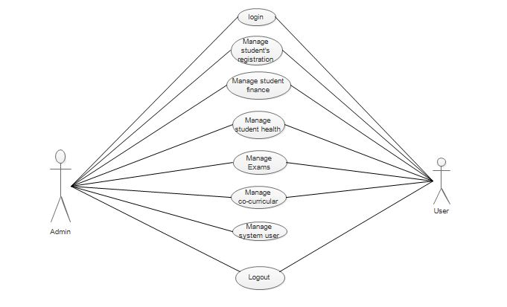

Sequence diagram

Below is a sequence diagram for the user/admin adding or registering a new student.

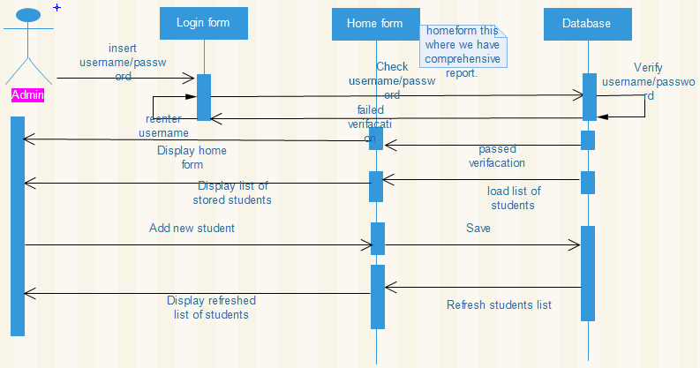

Class diagram

The below diagram show different classes, their attributes and operations associated with those specific classes.



**Physical design**

First screen

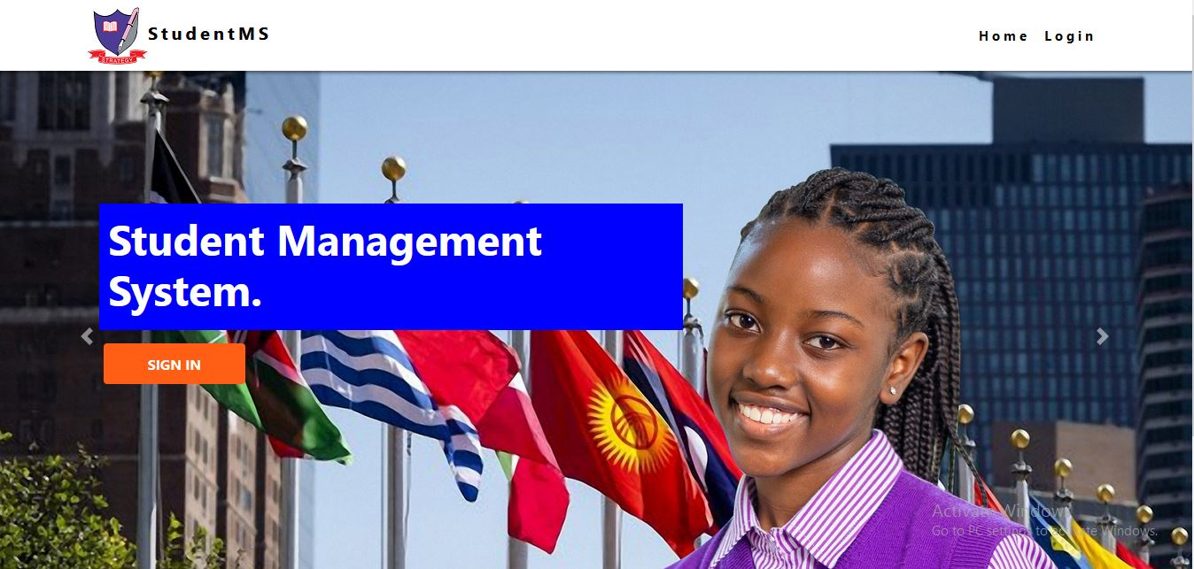

Login screen

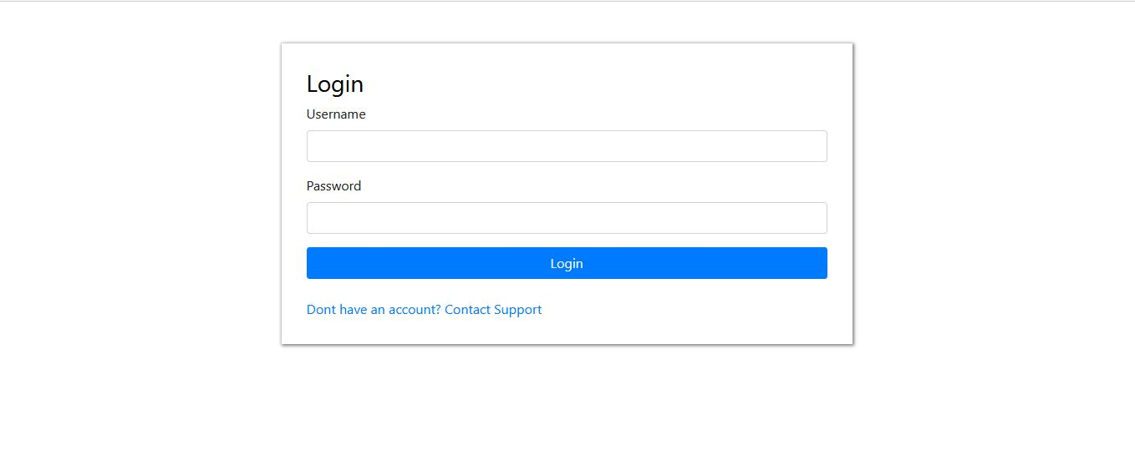

The Dashboard Screen

This dashboard appears immediately a user or the admin is granted access after the login credentials are verified. Therefore on the dashboard you will be able to access particular module depending on the User type. Below is a dashboard for the Admin

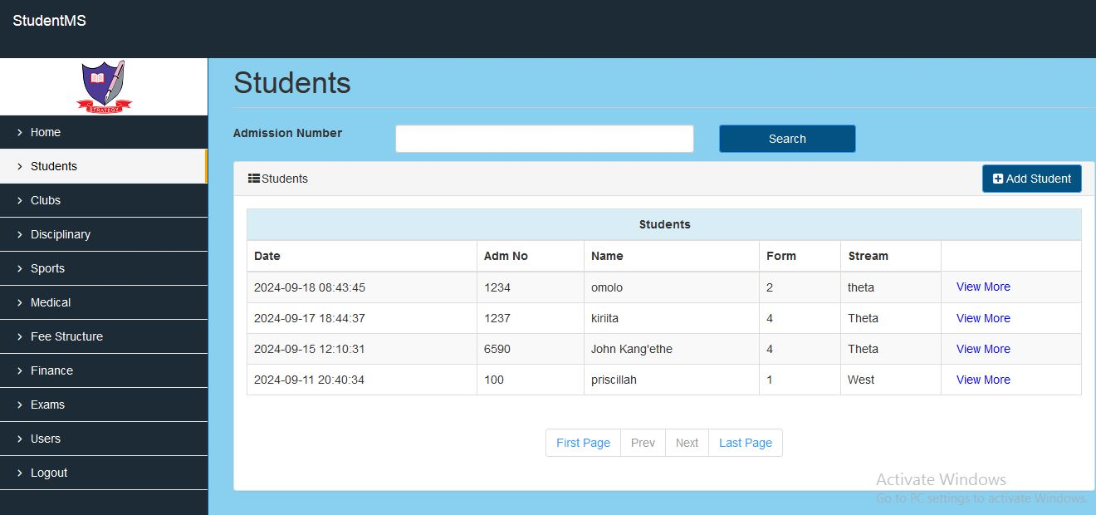

**Database design**

Below are different tables that will help me create a database that will be used by the Student management system to manage student’s information in different departments.

Each table contains the name of the field alongside the datatype it holds.

The tables are on the appendices:

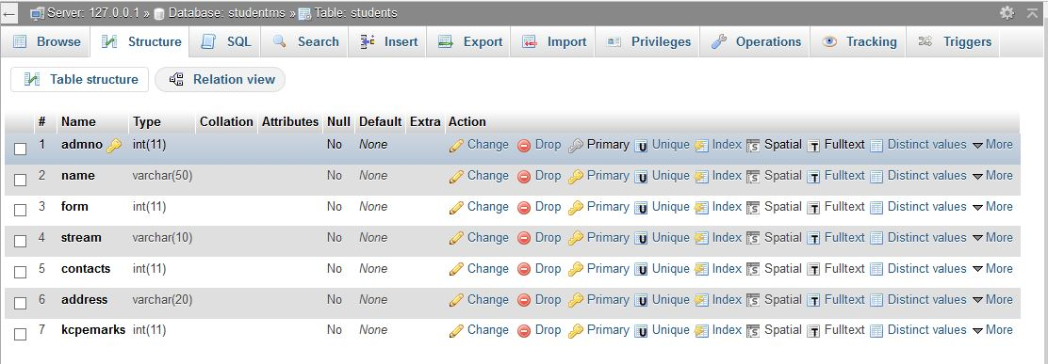

**CHAPTER 4**

**SYSTEM IMPLEMENTATION AND TESTING,**

**CONCLUSIONS AND RECOMMENDATIONS**

**4.1 Introduction**

This chapter will expound on the modules within the system, how they have been implemented

and the techniques used to test the modules.

**4.2 Environment and Tools**

The system has been implemented using the PHP to program the logic, HTML, CSS, and JS to

Design the user interfaces. The database used with this system is MYSQL.

**4.3 Code Generation**

Below are some of the processes in the system.

**4.3.1 Authentication Logic**

**<?php *class* User{**

**public *function* user_exists($email){**

**try {**

**$conn = *Db*::get()->conn;**

**$sql = "SELECT * FROM `users` WHERE `email` = :eml";**

**$stmt = $conn->prepare($sql);**

**$stmt->bindparam(":eml",$email);**

**$stmt->execute();**

**return ($stmt->rowCount() > 0);**

**} catch(*PDOException* $ex){**

**return false;**

**}**

**}**

**public *function* login($email,$pass){**

**try{**

**$conn = *Db*::get()->conn;**

**$salt = "1L2A7B0CFD96A012";**

**$pass = sha1($salt.$pass);**

**$sql = "SELECT * FROM `users` WHERE `username` = :eml AND `password` = :pass order by id limit 1";**

**$stmt = $conn->prepare($sql);**

**$stmt->bindparam(":eml", $email);**

**$stmt->bindparam(":pass", $pass);**

**$stmt->execute();**

**if($stmt->rowCount() === 1){**

**$row = $stmt->fetch(*PDO*::FETCH_OBJ);**

**$_SESSION['login_id'] = $row->id;**

**$_SESSION['login_type'] = $row->type;**

**$_SESSION['login_email'] = $row->username;**

**return true;}**

**return false;**

**} catch(*PDOException* $ex) {**

**return false;**

**}**

**}**

**}**

**?>**

**4.3.2 Exam Logic**

<?php

*class* Exam{

    public *function* exists($type,$admno,$form,$term,$subject){

        try {

            $conn = *Db*::get()->conn;

            $sql = "SELECT * FROM `exams` WHERE `type` = :type AND `admno` = :admno AND `form` = :form AND `term` = :term AND `subject` = :subject";

            $pstmt = $conn->prepare($sql);

            $pstmt->bindparam(":type", $type);

            $pstmt->bindparam(":admno", $admno);

            $pstmt->bindparam(":form", $form);

            $pstmt->bindparam(":term", $term);

            $pstmt->bindparam( ":subject", $subject);

            $pstmt->execute();

            return ($pstmt->rowCount() > 0);

        } catch(*PDOException* $ex){

            return false;

        }

    }

    public *function* get_score($type,$admno,$form,$term,$subject){

        try {

            $conn = *Db*::get()->conn;

            $sql = "SELECT * FROM `exams` WHERE `type` = :type AND `admno` = :admno AND `form` = :form AND `term` = :term AND `subject` = :subject";

            $pstmt = $conn->prepare($sql);

            $pstmt->bindparam(":type", $type);

            $pstmt->bindparam(":admno", $admno);

            $pstmt->bindparam(":form", $form);

            $pstmt->bindparam(":term", $term);

            $pstmt->bindparam( ":subject", $subject);

            $pstmt->execute();

            return ($pstmt->fetch(*PDO*::FETCH_OBJ)->score);

        } catch(*PDOException* $ex){

            return false;

        }

    }

    public *function* grade($score){

        $grade = "A";

        if($score > 87){

            $grade = "A";

        }else if($score > 82){

            $grade = "A-";

        }else if($score > 78){

            $grade = "B+";

        }else if($score > 71){

            $grade = "B";

        }else if($score > 62){

            $grade = "B-";

        }else if($score > 57){

            $grade = "C+";

        }else if($score > 52){

            $grade = "C";

        }else if($score > 47){

            $grade = "C-";

        }else if($score > 42){

            $grade = "D";

        }else if($score > 37){

            $grade = "D-";

        }else {

            $grade = "E";

        }

        return $grade;

    }

}

?>

**4.3.3 Finance Logic**

<?php

ob_start();

session_start();

require_once '../../classes/db.php';

require_once '../../classes/alert.php';

require_once '../../classes/user.php';

if (isset($_POST["add"])) {

    //get the request parameters

    $admno = trim($_POST["admno"]);

    $form = trim($_POST["form"]);

    $term = trim($_POST["term"]);

    $amount = trim($_POST["amount"]);

    $receipt = trim($_POST["receipt"]);

    $sql = "SELECT * from feestructure WHERE form = :form AND term = :term";

    $conn = *Db*::get()->conn;

    $stmt = $conn->prepare($sql);

    $stmt->bindparam("form", $form);

    $stmt->bindparam("term", $term);

    $stmt->execute();

    $fs = $stmt->fetch(*PDO*::FETCH_OBJ);

    $sql = "SELECT SUM(amount) as amount from finance WHERE admno = :admno AND form = :form AND term = :term";

    $conn = *Db*::get()->conn;

    $stmt = $conn->prepare($sql);

    $stmt->bindparam("admno", $admno);

    $stmt->bindparam("form", $form);

    $stmt->bindparam("term", $term);

    $stmt->execute();

    $paid = $stmt->fetch(*PDO*::FETCH_OBJ);

    if (($fs->amount - ($paid->amount + $amount)) < 0) {

        $status = *Alert*::create('danger', 'Save unsuccessful', 'Fee Exceeds Balance.');

    } else {

        $sql = "INSERT INTO `finance` (`admno`,`form`,`term`,`amount`,`receipt`) VALUES (:admno,:form,:term,:amount,:receipt)";

        $conn = *Db*::get()->conn;

        $stmt = $conn->prepare($sql);

        $stmt->bindparam(":admno", $admno);

        $stmt->bindparam(":form", $form);

        $stmt->bindparam(":form", $form);

        $stmt->bindparam(":term", $term);

        $stmt->bindparam(":amount", $amount);

        $stmt->bindparam(":receipt", $receipt);

        $stmt->execute();

        $id = $conn->lastInsertId();

        if ($id) {

            $status = *Alert*::create('success', 'Save successful', 'Fee Added.');

            header("refresh:3;view_finance.php");

        } else {

            $status = *Alert*::create('danger', 'Save unsuccessful', 'Error Occured.');

        }

    }

}

?>

**testing.**

During this stage testing was done to catch problems before the system is delivered to the client.

Below were the objectives of testing:

* To improve on the performance of the system.
* To ensure that the system would handle normal production of data timely and responsibly.
* To determine if the components of the system interfaces were working well.

Below were levels of testing used:

**4.4 System Testing**

To test the system, both white box and black box techniques were used. I as the developer tested the individual parts of the system, the integrated system and checked whether the system met its objectives. The users were also presented with a prototype of the system to feel and see the capabilities of such a system.

**4.4.1 Unit Testing**

The system has various modules; that is: the exam module, the finance module, the

Student module, medical module, clubs module and the sports module. Each of these modules is developed separately and necessary changes have been made to ensure that they are working simultaneously

**4.4.2 Integration Testing**

After the development of the individual modules, they were then merged together to come up

with the current system.

**4.4.3 Usability Testing**

A working prototype of the system was rolled out to individuals who volunteered to interact with it and see the capabilities of the system. They found the system to be quite user friendly and easy to interact with.

**4.5 Conclusions**

Even though a student management system is such an important aspect of student management, the usability of the current implementations remains to have limitations. Being able to use a student management system effectively and efficiently is the first step to improving student management in learning institutions . This research concentrated entirely on implementing usability in student management and has concluded that there is a need for such a system as discussed in this research document.

**Project achievements**

Development of student management system was successful and was able to achieve the following benefits:

* Good usable interfaces was created to enhance usability of the system.
* Storing of students information in the system was successful.
* Information security stored in the system to hinder unauthorized access through the use of the passwords.
* Facilitated easy and fast retrieval of information stored in the system.
* Kept track of each and every student performance.

**Challenges encountered**

* Virus attacks was a problem which lead to lose of data during transfer from one computer to another.
* A lot of money was spent since most research work was done in cyber cafes.

Lack of proper reference materials for developing the system was also a challenge

**4.5 Recommendations**

A lot of improvements can be done on the current version of the system. These include but no

limited to:

* The system can be adapted to suit all kinds of platforms; including android versions for

to improve user experience of users involved in generating reports instead of having to open the browsers every time

* The system can be improved to be able to contain a module for parents, guardians and sponsors.

**USER MANUAL**

**Installation requirements**

* A computer system with a good processor, 150 GB RAM and 1.5 GHz.
* A xampp server or Wamp server to host the database.
* Windows 2000 to windows 10 operating systems it’s where the system will run smoothly.

**What to find in the system.**

* **First Screen-** this is the first screen you see when you run the system or when the system is not in use.



* **Login form**- this is where you will key in the login credentials i.e. the username and password.



* **Dashboard** – this is a form containing several modules where a user can access details depending on the user type.

These modules are:

* Student – this where students registration details are filled in.
* Medical – this is where student’s medical information is recorded.
* Sports – student’s sports information are filled in here.
* Clubs – in this field students information concerning different clubs are recorded here.
* Finance – where finance information of a student is recorded.
* Academics – this where student performance is recorded.
* Disciplinary – this is where students discipline details are recorded.
* Users – this is where new users can be registered.



**To access the database**

* Click on Xampp server icon on the Taskbar
* Click on Phpmyadmin
* Select the Database name (studentms)
* You will see the available tables for example students, sports etc.
* Click on one table e.g. “students” then click Browse
* You will be able to see all details of the defined table.

Below shows database “studentms” and the tables contained in it.

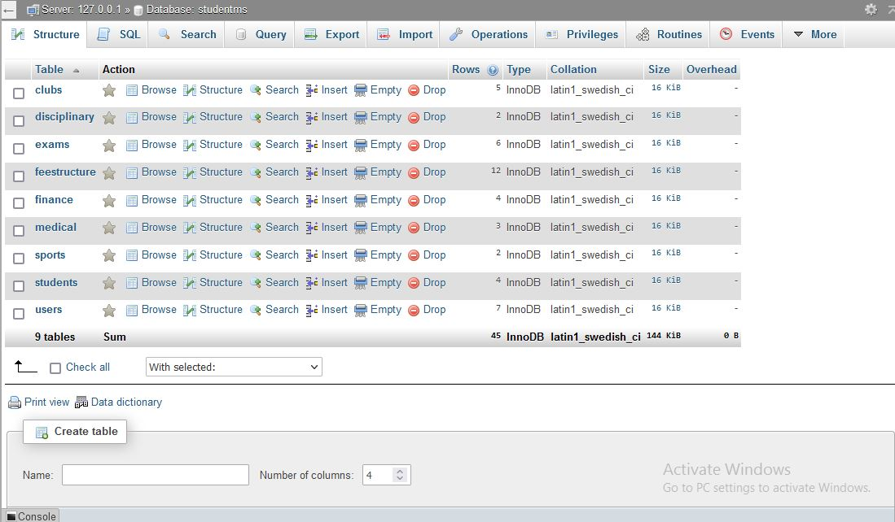

**How to use the system. (Registering a student).**

* Login to the system.
* On the username section type your username for example “principal@gmail.com.
* On the password section type your password for example “admin” which will appear on the screen as “****”.
* Click on the **LOGIN** button.
* A dashboard will display on the screen.
* Select the “students” module
* A student form will display as shown below. Key in the students details on the text fields.

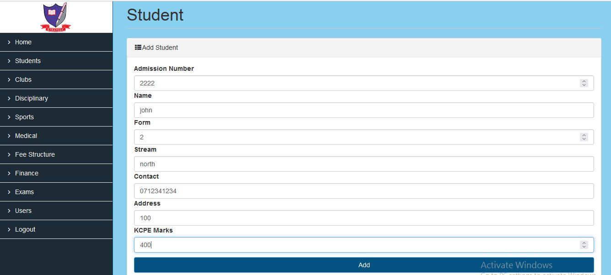

* Click **Add**button.

A message box will appear showing “**Save successful', 'Student Added**” if the process was successful and “**Save unsuccessful**” if the process was unsuccessful.

NOTE; the details will immediately disappear once you press the Add button

**References**

Gupta, R., & Kumar, S. (2020). Impact of student management systems on academic performance in higher education. Journal of Educational Technology systems, 48(4), 500-515.

Jones, M., & Brown, S. (2019). Usability evaluation of university’s student management system: A case study. Journal of Usability studies, 14(1), 45-65.

Sarker, S., & Molla, A. (2018) Challenges of integrating student management systems in educational institutions: A qualitative study. Education and Information Technologies, 23(3), 1147-1162.

**APPENDICES**

BUDGET

|  |  |  |
| --- | --- | --- |
| Item | Estimated cost (shillings) | Final cost (shillings) |
| Laptop | 35,000 | 32 ,000 |
| Transport | 600(per trip)*8=4,800 |  |
| Flash disk | 1,500 | 1,500 |
| Modem (safaricom) | 2,500 | 2,400 |
| Internet bundles | 3,000 |  |
| Hard disk(external) | 5,000 | 6,500 |
| Antivirus(Kaspersky) | 1,000 | 1,000 |
| Printing | 700 | 850 |
| Maintenance cost | 3,000 | 5000 |
| Miscellaneous | 5,000 | 3750 |
| Total | 61,500 | 66,500 |

Time scheduling in days

|  |  |  |  |  |  |  |
| --- | --- | --- | --- | --- | --- | --- |
| Activity | Duration in hours | Expected start date | Actual start date | Expected end date | Actual end date | Deliverables |
| Problem identification |  | 5/1/2024 | 7/1/2024 | 23/1/2024 | 28/1/2024 | Problem statement |
| Requirements/analysis | 74 | 30/1/2024 | 1/2/2024 | 7/2/2024 | 9/2/2024 | SRSD |
| Proposal writing | 50 | 10/4/2024 | 11/5/2024 | 17/5/2024 | 20/6/2024 | Proposal document |
| Proposal presentation | 5 | 23/6/2024 | 05/7/2024 | 05/7/2024 | 05/7/2024 | Project document |
| Data collection | 73 | 8/7/2024 | 10/7/2024 | 12/7/2024 | 13/7/2024 | Data collected |
| Designing | 336 | 14/7/2024 | 14/7/2024 | 27/7/2024 | 27/7/2024 | Design diagrams |
| Coding | 336 | 28/7/2024 | 28/7/2024 | 10/8/2024 | 10/8/2024 | Running code |
| testing | 84 | 14/8/2024 | 15/8/2024 | 18/8/2024 | 19/8/2024 | Working system |
| Final presentation | 10 | 22/8/2024 | 23/8/2024 | 23/8/2024 | 23/8/2024 | Project report |

Gantt chart

|  |  |  |  |  |  |  |  |  |  |  |  |  |  |  |  |  |  |  |  |  |  |  |  |  |  |  |  |  |  |  |  |  |  |  |  |  |  |  |  |  |
| --- | --- | --- | --- | --- | --- | --- | --- | --- | --- | --- | --- | --- | --- | --- | --- | --- | --- | --- | --- | --- | --- | --- | --- | --- | --- | --- | --- | --- | --- | --- | --- | --- | --- | --- | --- | --- | --- | --- | --- | --- |
| MONTHS  Week ending |  | JAN | | | | JAN | | | | FEB | | | | MAR | | | | APR | | | | MAY | | | | | JUNE | | | | | JULY | | | | AUG | | | | |
| 7 | 1  4 | 2  1 | 2  8 | 7 | 1  4 | 2  1 | 2  8 | 7 | 1  4 | 2  1 | 2  8 | 7 | 1  4 | 2  1 | 2  8 | 7 | 1  4 | 2  1 | 2  8 | 7 | 1  4 | 2  1 | 2  8 | 7 | | 1  4 | 2  1 | 2  8 | 7 | | 1  4 | 2  1 | 2  8 | | 7 | 1  4 | 2  1 | 2  8 |  | |  | |
| Activities | Dur  Hrs. |  |  |  |  |  |  |  |  |  |  |  |  |  |  |  |  |  |  |  |  |  |  |  |  |  | |  |  |  |  | |  |  |  | |  |  |  |  |  |  | |
| Requirements analysis |  |  |  |  |  |  |  |  |  |  |  |  |  |  |  |  |  |  |  |  |  |  |  |  |  |  | |  |  |  |  | |  |  |  | |  |  |  |  |  | |
| Proposal writing |  |  |  |  |  |  |  |  |  |  |  |  |  |  |  |  |  |  |  |  |  |  |  |  |  |  | |  |  |  |  | |  |  |  | |  |  |  |  |  | |
| Proposal presentations |  |  |  |  |  |  |  |  |  |  |  |  |  |  |  |  |  |  |  |  |  |  |  |  |  |  | |  |  |  |  | |  |  |  | |  |  |  |  |  | | | |
| Data collection |  |  |  |  |  |  |  |  |  |  |  |  |  |  |  |  |  |  |  |  |  |  |  |  |  |  | |  |  |  |  | |  |  |  | |  |  |  |  |  | | | |
| Designs |  |  |  |  |  |  |  |  |  |  |  |  |  |  |  |  |  |  |  |  |  |  |  |  |  |  | |  |  |  |  | |  |  |  | |  |  |  |  |  | | | |
| Coding |  |  |  |  |  |  |  |  |  |  |  |  |  |  |  |  |  |  |  |  |  |  |  |  |  |  | |  |  |  |  | |  |  |  | |  |  |  |  |  | | | |
| Testing |  |  |  |  |  |  |  |  |  |  |  |  |  |  |  |  |  |  |  |  |  |  |  |  |  |  | |  |  |  |  | |  |  |  | |  |  |  |  |  | | | |
| Final presentation |  |  |  |  |  |  |  |  |  |  |  |  |  |  |  |  |  |  |  |  |  |  |  |  |  |  | |  |  |  |  | |  |  |  | |  |  |  |  |  | | | |
| Documentation |  |  |  |  |  |  |  |  |  |  |  |  |  |  |  |  |  |  |  |  |  |  |  |  |  |  | |  |  |  |  | |  |  |  | |  |  |  |  |  | | | |

KEY

Proposed dates

|  |
| --- |
|  |

**Students table**

|  |  |
| --- | --- |
| **Field Name** | **Type** |
| AdmNo | Int(11) |
| Name | Varchar(50) |
| Form | Int(11) |
| Stream | Varchar(10) |
| Contacts | Int(10) |
| Address | Varchar(20) |
| KcpeMarks | Int(3) |

**User Table**

|  |  |
| --- | --- |
| **Field Name** | **Type** |
| Id | Int((11) |
| Username | Varchar(30) |
| Password | Varchar(20) |
| UserType | Varchar(15) |

**Medical Tables**

|  |  |
| --- | --- |
| **Field Name** | **Type** |
| Id | Int(11) |
| Date | Date |
| Admno | Int(11) |
| Age | Int(5) |
| Sickness | Varchar(10) |
| Allergies | Varchar(20) |
| Treatment | Varchar(20) |
| Datecleared | Date |

**Finance table**

|  |  |
| --- | --- |
| **Field Name** | **Type** |
| Id | Int(11) |
| Date | Date |
| Admno | Int(11) |
| From | Int(2) |
| Term | Varchar(10) |
| ReceiptNo | Int(20) |
| TotalFee | Double |
| FeePaid | Double |
| Feebalance | Double |

**Disciplinary Tables**

|  |  |
| --- | --- |
| **Field Name** | **Type** |
| Id | Int(11) |
| Date | Date |
| Admno | Int(11) |
| Casereported | Varchar(50) |
| Punishment | Varchar(50) |
| Cleared | TinyInt(5) |

**Sports Table**

|  |  |
| --- | --- |
| **Field Name** | **Type** |
| Id | Int(11) |
| Admno | Int(10) |
| Sport | Varchar(11) |
| Rank | Varchar(50) |
| DateRegistered | Date |
| Datequited | Date |

**Clubs Table**

|  |  |
| --- | --- |
| **Field Name** | **Type** |
| Id | Int(11) |
| Admno | Int(10) |
| Club | Varchar(11) |
| Rank | Varchar(50) |
| Dateregistered | Date |
| Datequited | Date |

**Sample questionnaire for feasibility study**

I am a finalist student taking Bachelors in Information Technology in Jomo Kenyatta University of Agriculture and Technology Please fill in the required details. Indicate your answer on the dotted line below every question. I will appreciate all your response this is because I will be able to gather all the information which will assist me in developing this system. Thank you.

1. How much does the school spend on buying papers and other writing materials?

……………………………………………………………………………………

1. Do you think this system will reduce the costs that has always be incurred on stationery?

……………………………………………………………………………………

1. Do you think the institution is economically ready to fund the development of a new system?

…………………………………………………………………………………...

1. How many computers does the institution have?

……………………………………………………………………………………

1. What types of computers are used in the institution?

Laptops

Desktops

1. What is the RAM capacity of each computer?

……………………………………………………………………………………

1. What other softwares have been installed in the computers?

…………………………………………………………………………………....

1. Do you have basic computer skills?

…………………………………………………………………………………….

1. Have you used other softwares earlier?

…………………………………………………………………………………….

1. What challenges have you encountered while using other softwares to accomplish your tasks on daily basis?

……………………………………………………………………………………

……………………………………………………………………………………

1. Do you think the system will improve the performance as compared to the current system? Give a reason for your answer.

……………………………………………………………………………………

1. What rules has been put in place to enhance students information is safe from an authorized people?

…………………………………………………………………………………….

1. Who should be able to access the student’s information?

……………………………………………………………………………………...

1. What are the different departments in the school?

…………………………………………………………………………………………

1. Who should be the user of the system from each department?

……………………………………………………………………………………….

1. How does different departments in the school perform their duties on matters concerning student’s information?

………………………………………………………………………………………

1. What functions would you like the system to perform? Choose and tick from the functions listed below.

Record

Retrieve

Calculate

Delete

Authenticate

1. Do you have instances where different students share the same admission numbers leading to difficulties when retrieving specific student’s information?

…………………………………………………………………………………………

1. How do you come up with the final exam results, having done CAT1, CAT2 and the end of term exam?

…………………………………………………………………………………………..

1. What is the grading system for final exam results from different forms?

……………………………………………………………………………………………

1. What would you like the system to look like in terms of usability, putting in mind that some systems are much complex compared to others?

……………………………………………………………………………………………….